

Staff – Microsoft Teams Quick Guide

Use of “Classrooms” and setting online homework and tasks


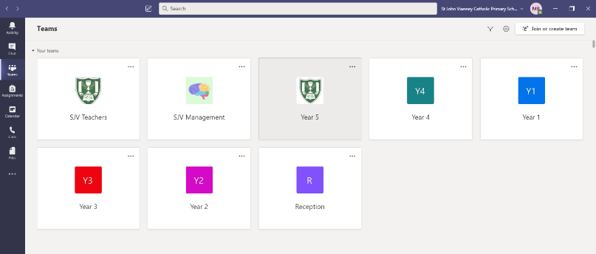
- Sign into teams and you will see at the ‘Teams’ you are part of.
- Year groups will include all the children and teachers linked to that year.
- Click on the appropriate year group ‘Team’

- On the next page there are several ‘tabs’ to remember which you will need to set homework in September.
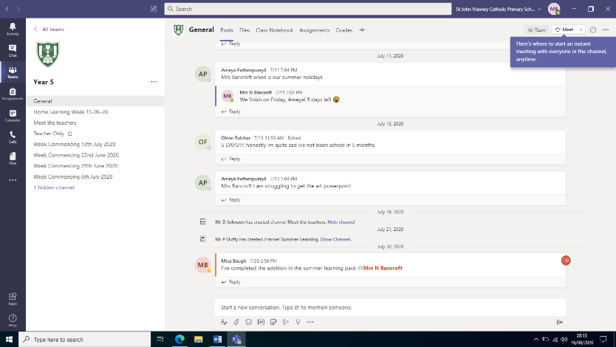
- Under the team name, for example ‘Year 5’, you will see all the channels within this Team. Our aim in September is to have the following (year group specific):

- General (standard)
- All Year 6
- Class 6B
- Class 60
New channels can be added but we don’t want work to be in too many places as we get started!
- Across the top you will see the tabs - Posts, Files, Class Notebook, Assignments and Grades
Setting Homework:
- Ensure you are under the ‘General’ part of the team and select ‘Assignments’
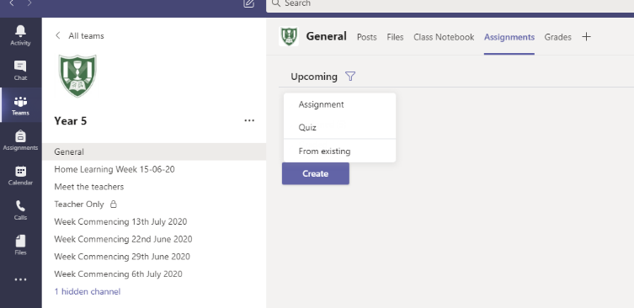
- Assignments can take the form of normal homework – sentences, spellings, research, comprehension, maths etc or in the form of a quiz which you can create easily.
- Select ‘Create’ and ‘Assignment’
- You will then be redirected to a screen to create your task/assignment.

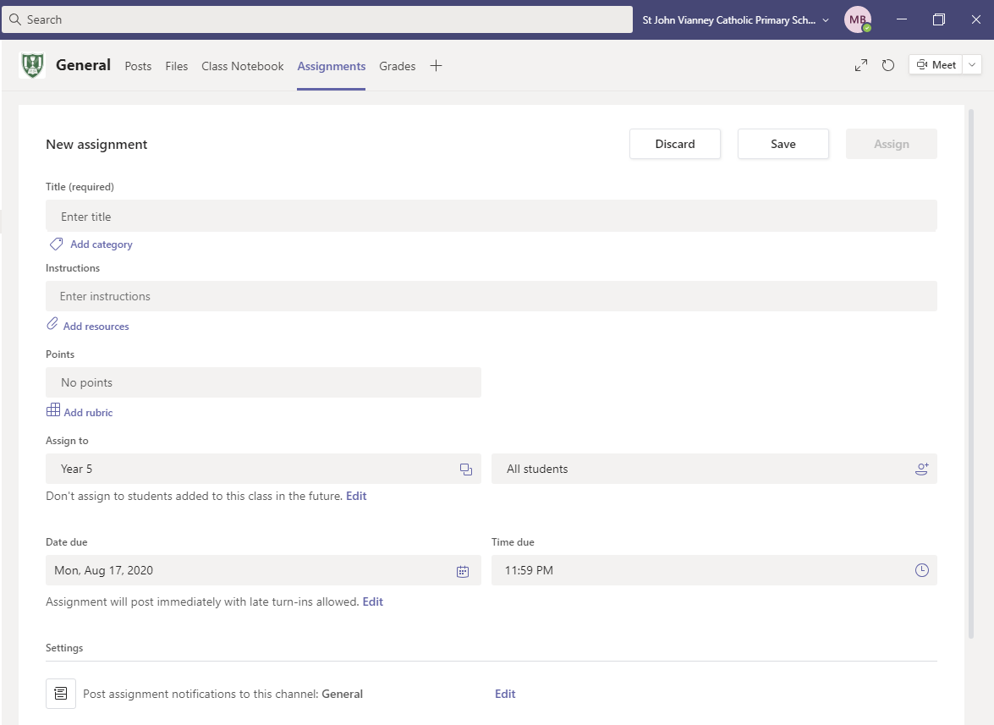
- Title - What do you want your homework to be called?
- Instructions – Wha do they need to do? Remember you are not only writing this for the childre, this is what parents will see too!
- Points – ignore this.
- Assign to – this remains as your year group and all students is automatically selected unless you assign to specific children (SEN/absent children etc).
- Date/time due – amend appropriately
- Settings – IMPORTANT PART!
- If you are posting to all year group, select ‘edit’ and select the appropriate channel name (for example, ‘All Year 6’)
- If you only want to post to your class, select ‘edit’ and select your class name.
- Select ‘done’
- Return to the top of the page and select ‘Assign’ to post immediately, or ‘Save’ to keep as a draft ready to post at a later time.

Creating a quiz:
- Ensure you are under the ‘General’ part of the team and select ‘Assignments’
- Select ‘Create’ and ‘Quiz’
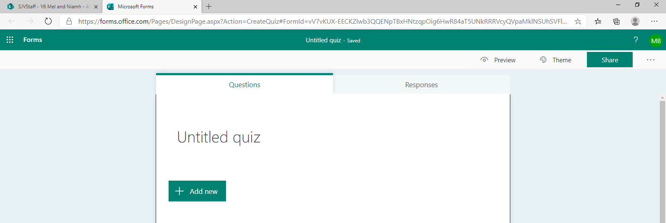
- This will take you to a new page, select ‘New Quiz’ which will redirect you to ‘Microsoft Forms’ page.
- Give your quiz a title – for example, ‘Responding to a Text’
- Select ‘Add new’

- You will then be given the following choices:
- Choice
- Text
- Rating
- Date
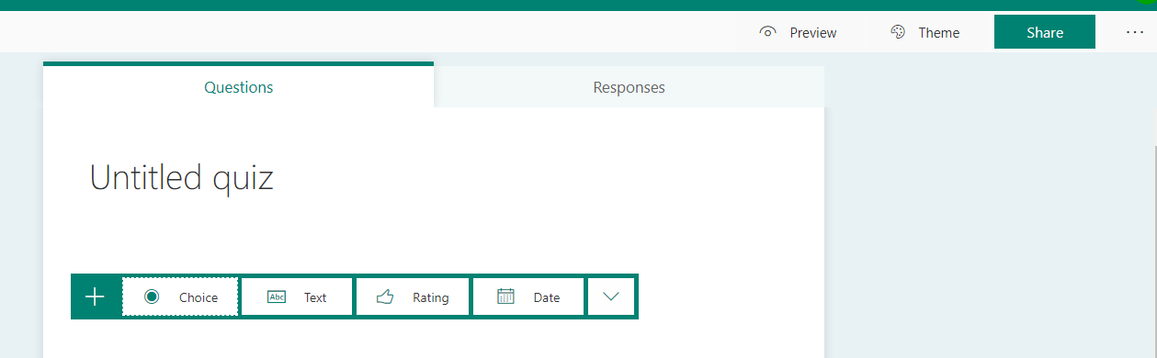

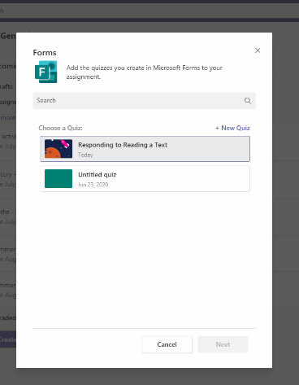
- Explore each option to vary the style of questions in your quiz.
- You can use the ‘Theme’ tab to change the appearance of the quiz and the ‘Preview’ button is there to view it completed.
- The quiz automatically saves and then, return to ‘General’, click ‘Create Assignment – Quiz’ and your quiz will be listed.
- Select the correct quiz and select ‘Next’
- You will then be redirected to the ‘New assignments’ page as explained before – follow upload steps given.

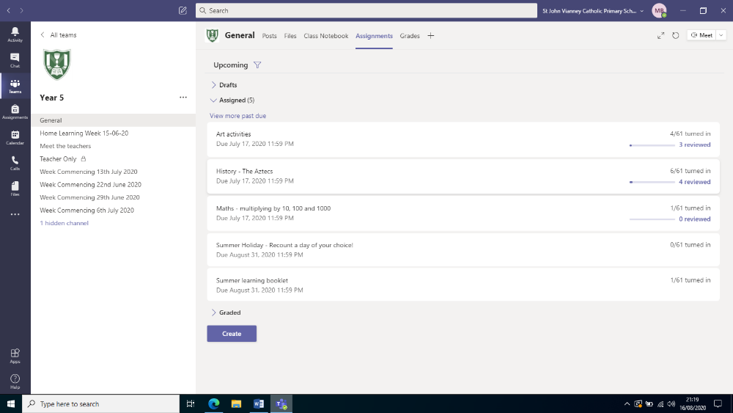
Feedback and monitoring:
- Clicking on the assignments once published allows you to who has/hasn’t viewed the task and who has ‘Turned in’ which means completed the task.
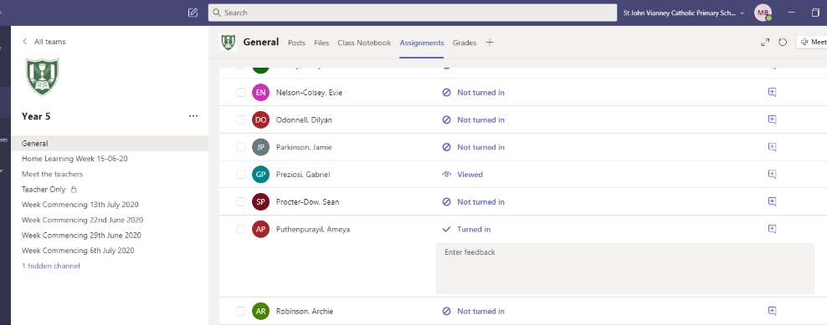
- When clicking on the assignment, it will give individual names in order to track who is and is not accessing Teams.
- Once homework is ‘Turned in’ – clicking on the ‘+’ icon allows staff to give 1:1 feedback on the work completed.

